**Word Break Problem**

Given an input string and a dictionary of words, find out if the input string can be segmented into a space-separated sequence of dictionary words. See following examples for more details.  
This is a famous Google interview question, also being asked by many other companies now a days.

Consider the following dictionary

{ i, like, sam, sung, samsung, mobile, ice,

cream, icecream, man, go, mango}

Input: ilike

Output: Yes

The string can be segmented as "i like".

Input: ilikesamsung

Output: Yes

The string can be segmented as "i like samsung"

or "i like sam sung".

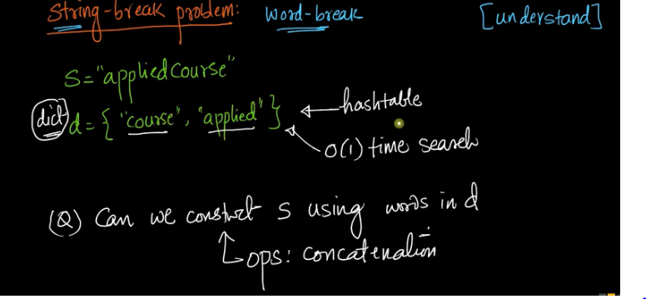

Only concatenation operation is allowed here.

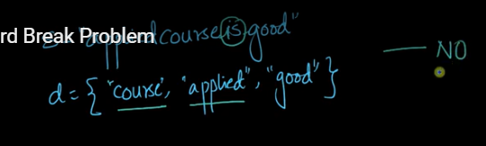

"is" missing, So answer is No.

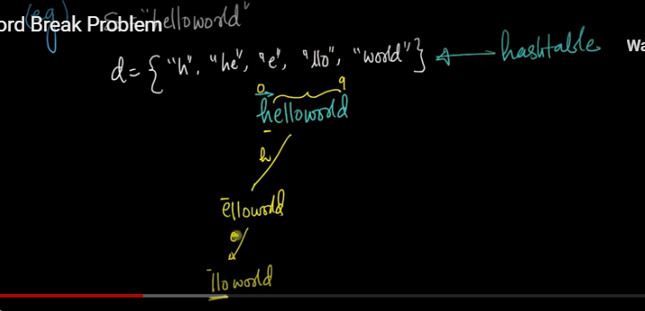

I will go from left to right and find the matching characters.

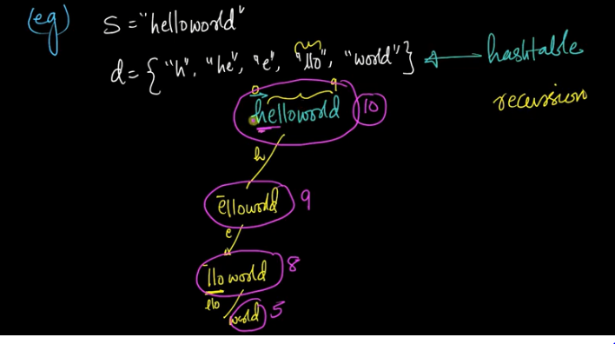

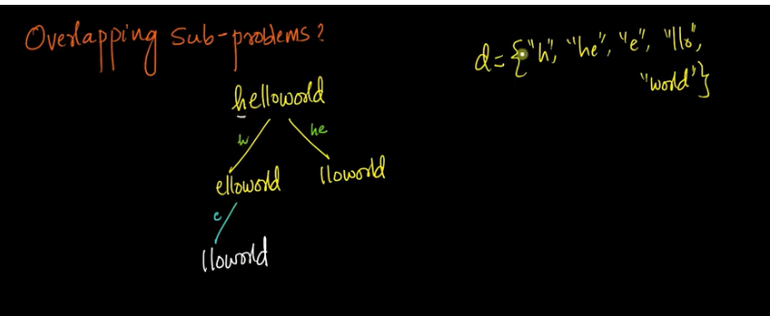

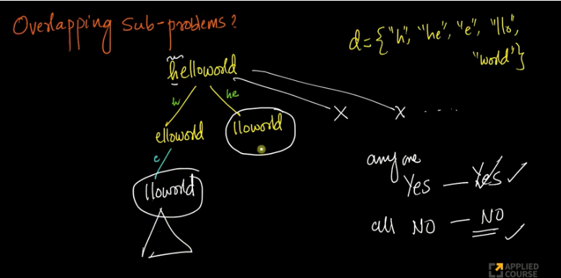

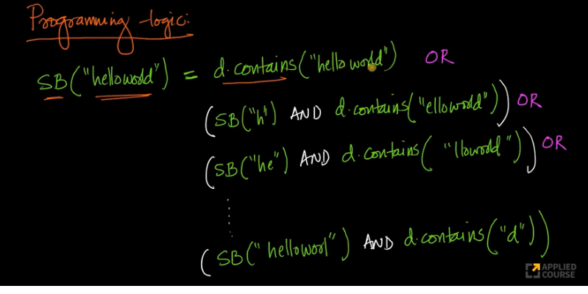

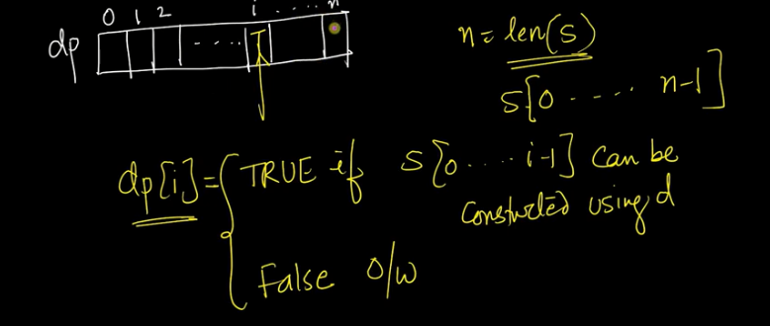

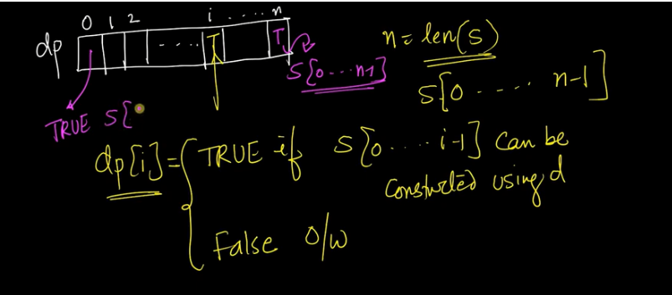

Zero value will be filled as TRUE by default.

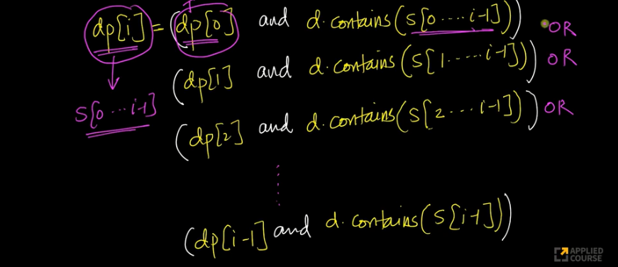

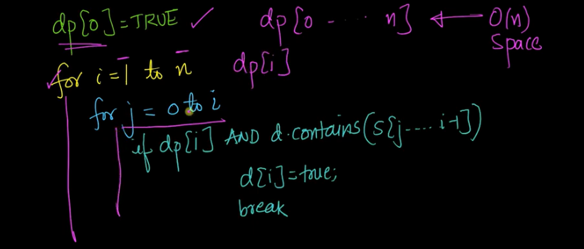

def wordbreak(s, words):

if len(s) == 0:

return True

# Test all prefixes

for i in range(1, len(s)+1):

sub = s[:i]

if not sub in words: continue

if wordbreak(s[i:], words):

return True

return False

### DP? O(n^2)

# cut(i) = s[:i] can be splitted

# cut(i+1) = OR{cut(j) and s[j:i] is a word for 0 <= j < i}

def wordbreak\_DP(s, words):

words = set(words)

cut = {0: True}

for i in range(1,len(s)+1):

cut[i] = False

for j in range(i):

if cut[j] and s[j:i] in words:

cut[i] = True

break

return cut[len(s)]

memo = {}

def wordbreak\_memo(s, words):

if s == '': return True

global memo

if s in memo: return memo[s]

for i in range(1,len(s)+1):

sub = s[:i]

if not sub in words: continue

if wordbreak\_memo(s[i:], words):

memo[s] = True#; print memo

return True

return False

if \_\_name\_\_ == '\_\_main\_\_':

s = "catsanddogseat"

words = set(["cat", "cats", "and", "sand", "dog", "dogs", "eat", "seat"])

print(wordbreak(s, words))

print (wordbreak\_DP(s, words))

print (wordbreak\_memo(s, words))

**Longest Increasing Subsequence**

Now, let us discuss the Longest Increasing Subsequence (LIS) problem as an example problem that can be solved using Dynamic Programming.  
The Longest Increasing Subsequence (LIS) problem is to find the length of the longest subsequence of a given sequence such that all elements of the subsequence are sorted in increasing order. For example, the length of LIS for {10, 22, 9, 33, 21, 50, 41, 60, 80} is 6 and LIS is {10, 22, 33, 50, 60, 80}.  
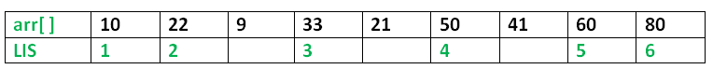

**Examples:**

**Input:** arr[] = {3, 10, 2, 1, 20}

**Output:** Length of LIS = 3

The longest increasing subsequence is 3, 10, 20

**Input:** arr[] = {3, 2}

**Output:** Length of LIS = 1

The longest increasing subsequences are {3} and {2}

**Input:** arr[] = {50, 3, 10, 7, 40, 80}

**Output:** Length of LIS = 4

The longest increasing subsequence is {3, 7, 40, 80}

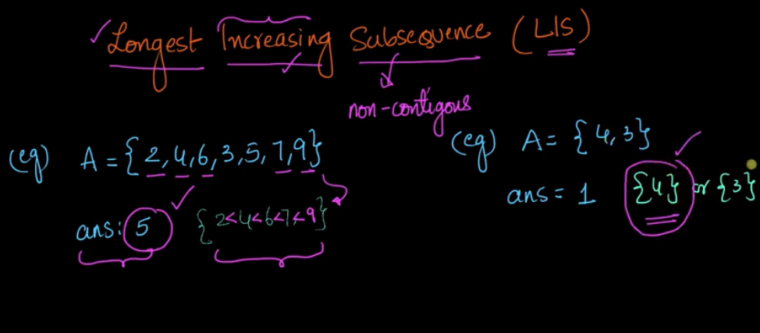

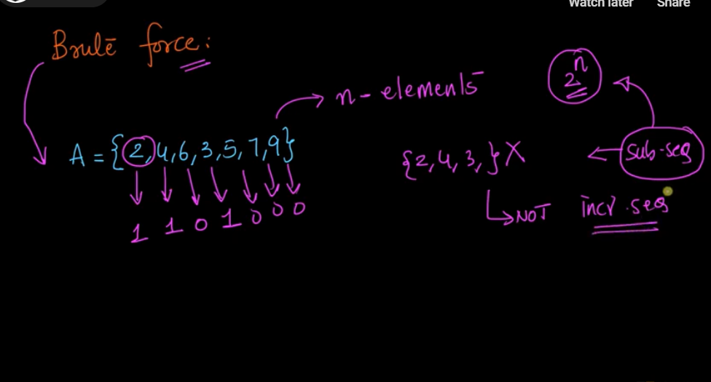

For each letter, we need to check if it is present or not and generate all the subsequnce which order of 2 power n and then check if it is increasing or not and then calculate the longest increasing subsequnce.

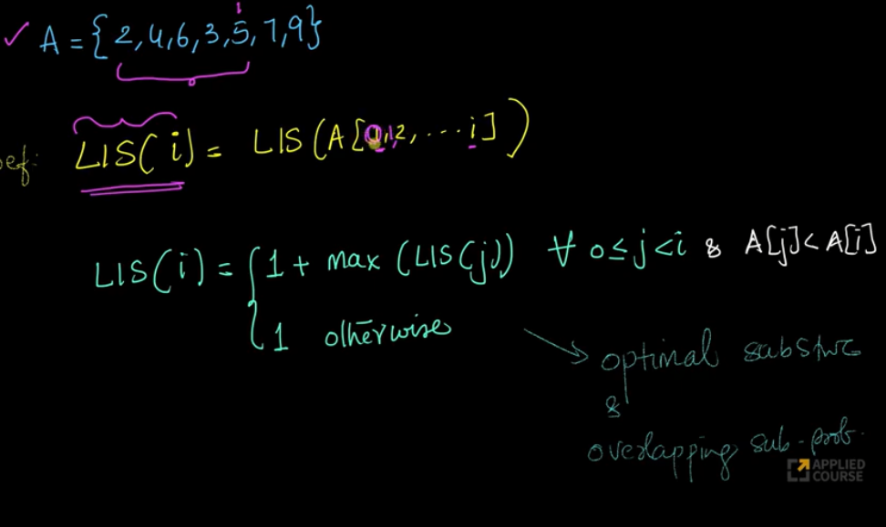

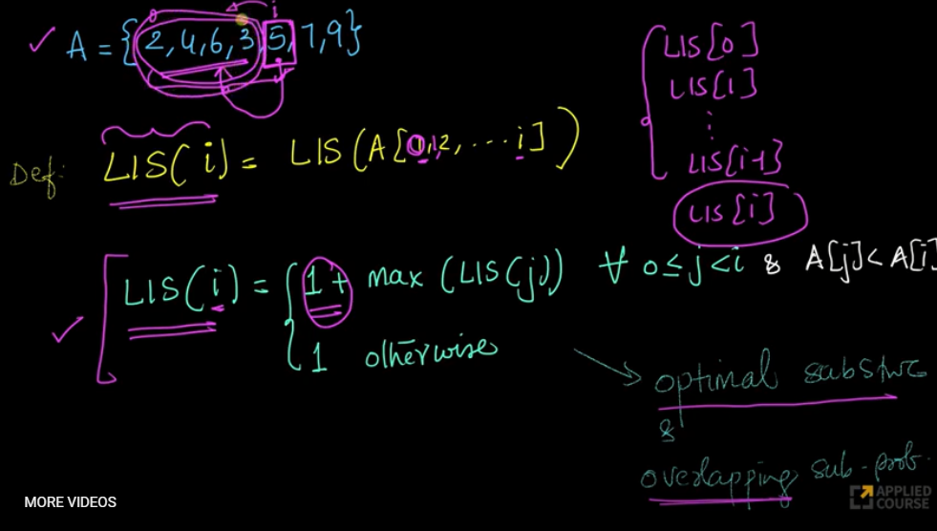

Here we are taking 1+ becuase for exmaple 5 is added as part of longest increasing subsequnce.

There are three cases

1) 5 is part of longestsubsqunece

2) 5 is not part

3) Subsequnce canstart from 5.

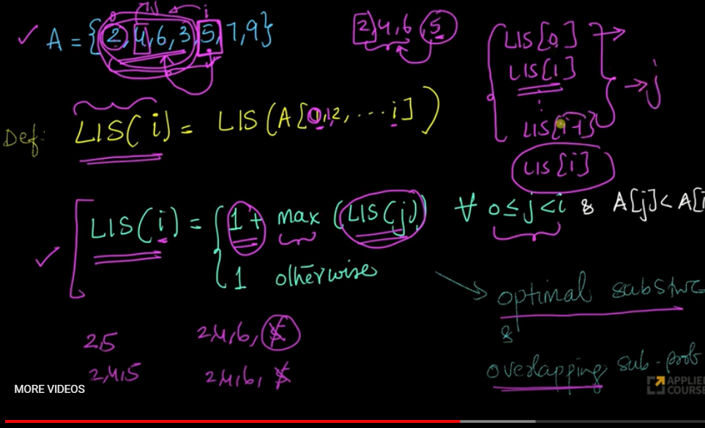

It says take all the possible values which are less than the current index and take the maximum of it.

For example, we take 5, then we need to construct all the subsequnce like (2,5), (2,4,5), (2,4,6,here we cananot add 5 here) then take the value which is maximum of length.

Here we need to compute for L[i] with all the subsequnce by taking L[0],L[1] and everything.

Here we need to take 1 in otherwise condition as our subsequnce may start from 1 or we have a boundry case.

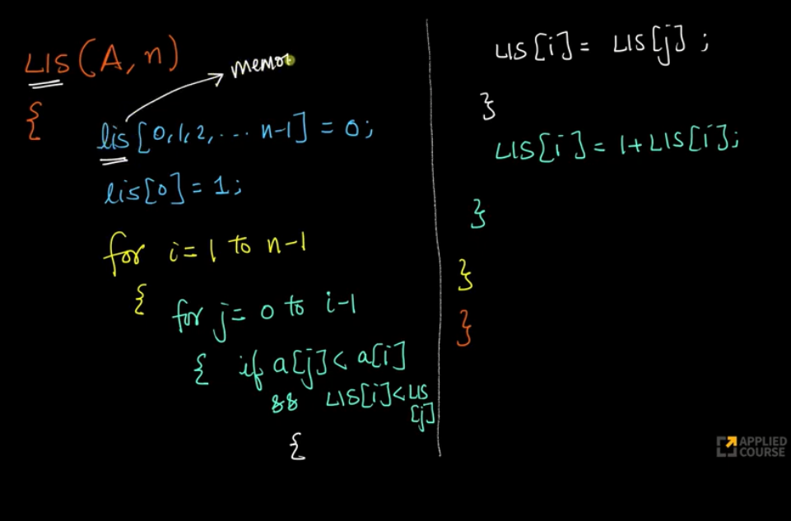

here we need to consider LIS[0,1,2,3...N-1] which is used to store L[0],L[1] etc..

Let’s take an example and see how this code works? For example, given array A = {2,4,6,3,5,7,9}

Initialize LIS[0] =1, that means there is an increasing subsequence of length 1 at index 0.  
For i = 1 i.e 4, check for j=0 to 1, excluding index 1. A[0] < A[1], hence LIS length is 2 (LIS[0] + 1 ).

For i = 2, i.e. 6 , check j = 0 to 2.  and check that LIS[0] = 1 and LIS[1] =2. Max LIS[j] for j=0 to  2 is 2. LIS[2] = 3 (LIS[1] +1).  
For i =3 i.e 3, check from 0 to 3, Max LIS till index 3 will be LIS[3] = 2 because only A[0] is less than A[3]. Hence longest subsequence ending with i = 3 will have length only of 2.  LIS[3] = 2  
For i = 4, i.e.5 Max LIS is again 3 which includes {2,4,5} or {2,3,5}  
For i = 5, i.e 7, Max LIS is 4 which includes {2,4,5,7} or {2,3,5,7} or {2,4,6,7}  
For i = 6, i.e 9, Max LIS is 5 which includes {2,4,5,7,9} or {2,3,5,7,9} or {2,4,6,7,9}

Therefore, longest increasing subsequence is 6 for given array.

Then, L(i) can be recursively written as:

L(i) = 1 + max( L(j) ) where 0 < j < i and arr[j] < arr[i]; or

L(i) = 1, if no such j exists.

To find the LIS for a given array, we need to return max(L(i)) where 0 < i < n.

Formally, the length of the longest increasing subsequence ending at index i, will be 1 greater than the maximum of lengths of all longest increasing subsequences ending at indices before i, where arr[j] < arr[i] (j < i). Thus, we see the LIS problem satisfies the optimal substructure property as the main problem can be solved using solutions to subproblems. The recursive tree given below will make the approach clearer:

Input : arr[] = {3, 10, 2, 11}

**f(i): Denotes LIS of subarray ending at index ‘i’**

(LIS(1)=1)

f(4) {f(4) = 1 + max(f(1), f(2), f(3))}

/ | \

f(1) f(2) f(3) {f(3) = 1, f(2) and f(1) are > f(3)}

| | \

f(1) f(2) f(1) {f(2) = 1 + max(f(1)}

|

f(1) {f(1) = 1}

# global variable to store the maximum

global maximum

def \_lis(arr , n ):

    # to allow the access of global variable

    global maximum

    # Base Case

    if n == 1 :

        return 1

    # maxEndingHere is the length of LIS ending with arr[n-1]

    maxEndingHere = 1

    """Recursively get all LIS ending with arr[0], arr[1]..arr[n-2]

       IF arr[n-1] is maller than arr[n-1], and max ending with

       arr[n-1] needs to be updated, then update it"""

    for i in xrange(1, n):

        res = \_lis(arr , i)

        if arr[i-1] < arr[n-1] and res+1 > maxEndingHere:

            maxEndingHere = res +1

    # Compare maxEndingHere with overall maximum. And

    # update the overall maximum if needed

    maximum = max(maximum , maxEndingHere)

    return maxEndingHere

def lis(arr):

    # to allow the access of global variable

    global maximum

    # lenght of arr

    n = len(arr)

    # maximum variable holds the result

    maximum = 1

    # The function \_lis() stores its result in maximum

    \_lis(arr , n)

    return maximum

# Driver program to test the above function

arr = [10 , 22 , 9 , 33 , 21 , 50 , 41 , 60]

n = len(arr)

print "Length of lis is ", lis(arr)

# This code is contributed by NIKHIL KUMAR SINGH

**Complexity Analysis:**

* **Time Complexity:** The time complexity of this recursive approach is exponential as there is a case of overlapping subproblems as explained in the recursive tree diagram above.
* **Auxiliary Space:** O(1). No external space used for storing values apart from the internal stack space.

**Method 2:** Dynamic Programming.

Input : arr[] = {3, 10, 2, 11}

LIS[] = {1, 1, 1, 1} (initially)

**Iteration-wise simulation :**

1. arr[2] > arr[1] {LIS[2] = max(LIS [2], LIS[1]+1)=2}
2. arr[3] < arr[1] {No change}
3. arr[3] < arr[2] {No change}
4. arr[4] > arr[1] {LIS[4] = max(LIS [4], LIS[1]+1)=2}
5. arr[4] > arr[2] {LIS[4] = max(LIS [4], LIS[2]+1)=3}
6. arr[4] > arr[3] {LIS[4] = max(LIS [4], LIS[3]+1)=3}

We can avoid recomputation of subproblems by using tabulation as shown in the below code:  
Below is the implementation of the above approach:

# lis returns length of the longest

# increasing subsequence in arr of size n

def lis(arr):

    n = len(arr)

    # Declare the list (array) for LIS and

    # initialize LIS values for all indexes

    lis = [1]\*n

    # Compute optimized LIS values in bottom up manner

    for i in range (1 , n):

        for j in range(0 , i):

            if arr[i] > arr[j] and lis[i]< lis[j] + 1 :

                lis[i] = lis[j]+1

    # Initialize maximum to 0 to get

    # the maximum of all LIS

    maximum = 0

    # Pick maximum of all LIS values

    for i in range(n):

        maximum = max(maximum , lis[i])

    return maximum

# end of lis function

# Driver program to test above function

arr = [10, 22, 9, 33, 21, 50, 41, 60]

print "Length of lis is", lis(arr)

# This code is contributed by Nikhil Kumar Singh

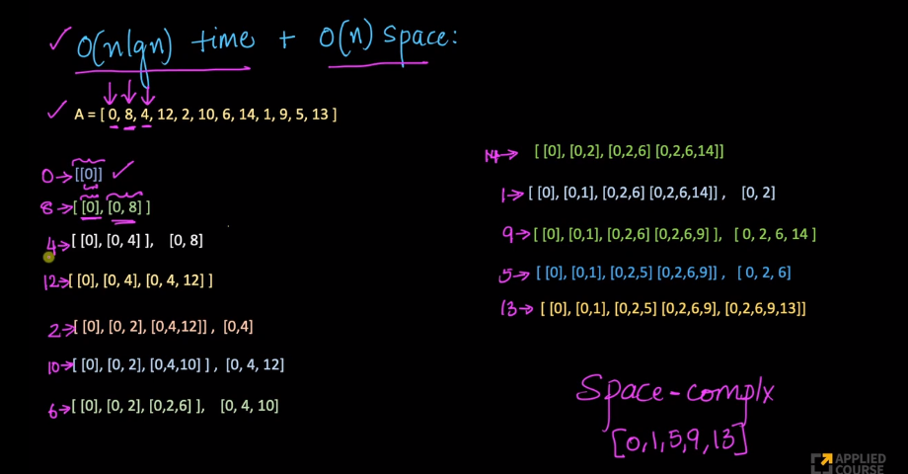

Here in the second case 8 is greater than 0, then only we can add 8.

in the third case,4 is less than 8 we cannot concatenatee with 8 and 4.

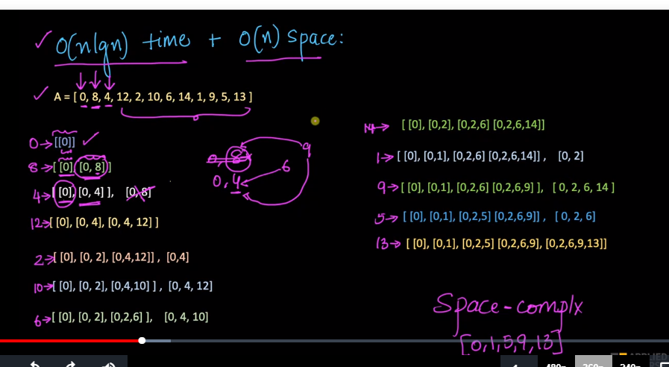

Here in the third case, anything that can be concatenated with 0,8 can be concatenated with 0,4. So here we are putting 0,4 here and discarding 0,8.

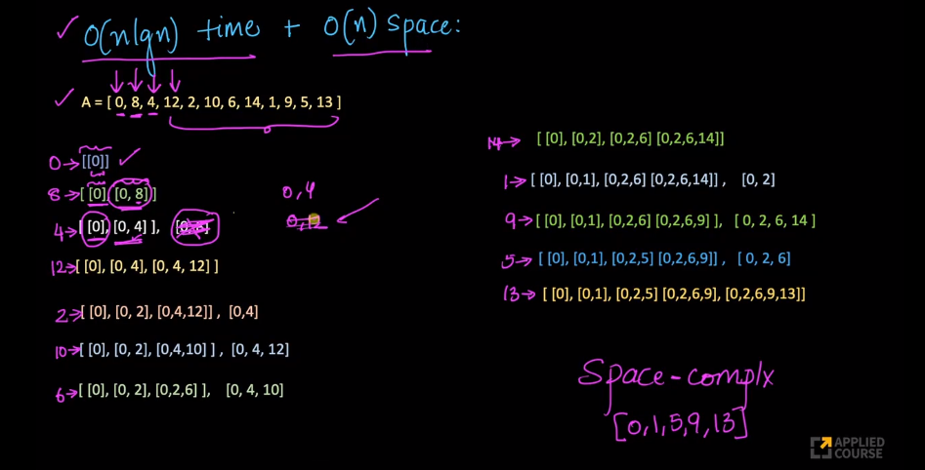

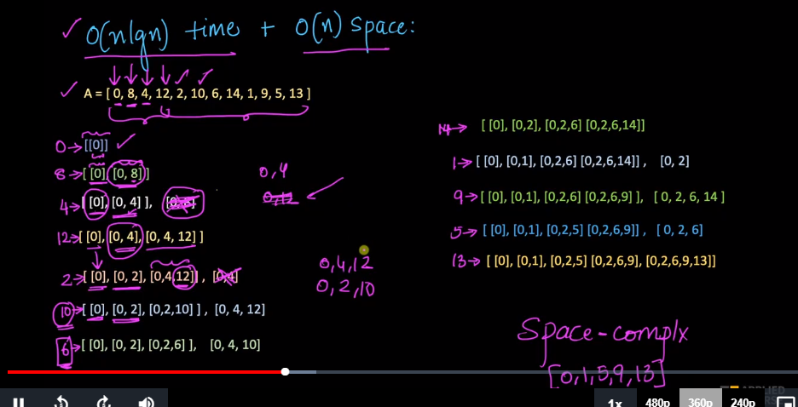

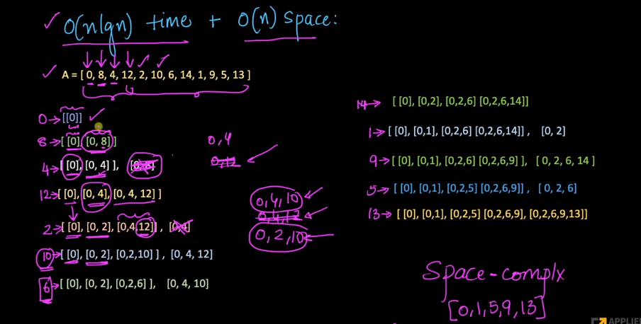

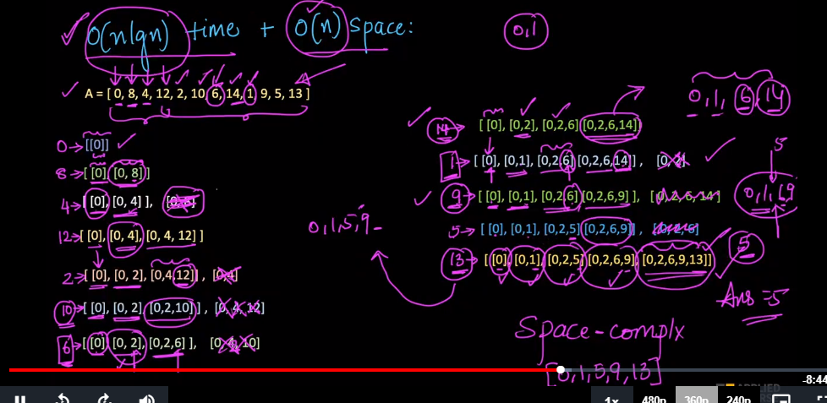

Instead of stroing the entire list by list, we just need the maximum elemt in each of the list.

for example in item 14, we will only keep 0,2,6,14 which are the largest elemt of each of the list.

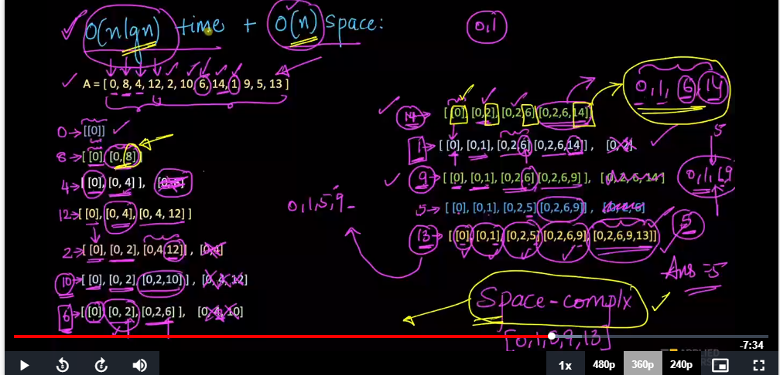

Here the number of character in each list will be order of n. Means first list wil contain only one character,second will contain 2 character, 3 will contain 3 character etc..

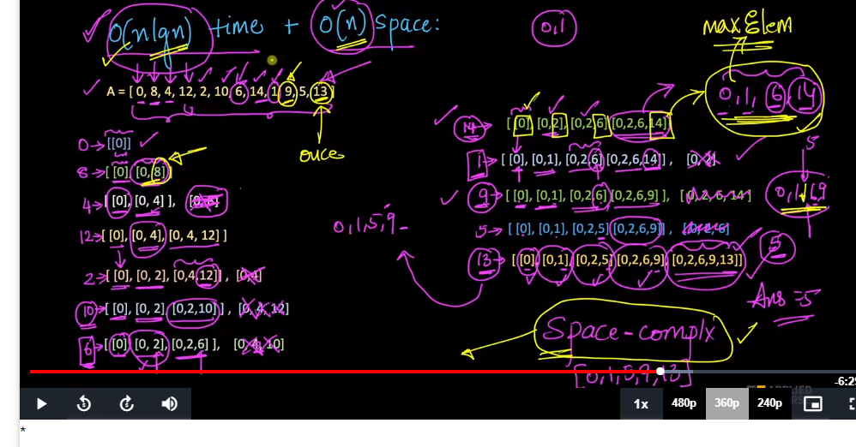

Here we need to do a binary seach out from the list on where we can place the element is 0(nlogn).

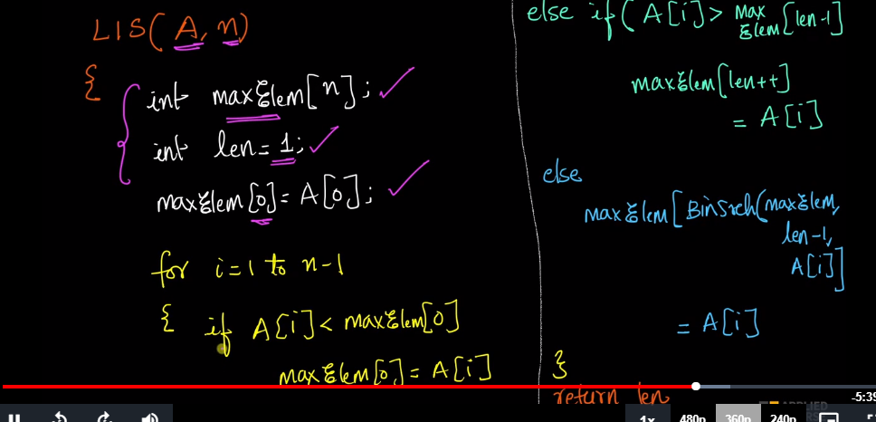

**Subset Sum Problem**

Given a set of non-negative integers, and a value *sum*, determine if there is a subset of the given set with sum equal to given *sum*.

**Example:**

**Input:** set[] = {3, 34, 4, 12, 5, 2}, sum = 9

**Output:** True

There is a subset (4, 5) with sum 9.

**Input:** set[] = {3, 34, 4, 12, 5, 2}, sum = 30

**Output:** False

There is no subset that add up to 30.

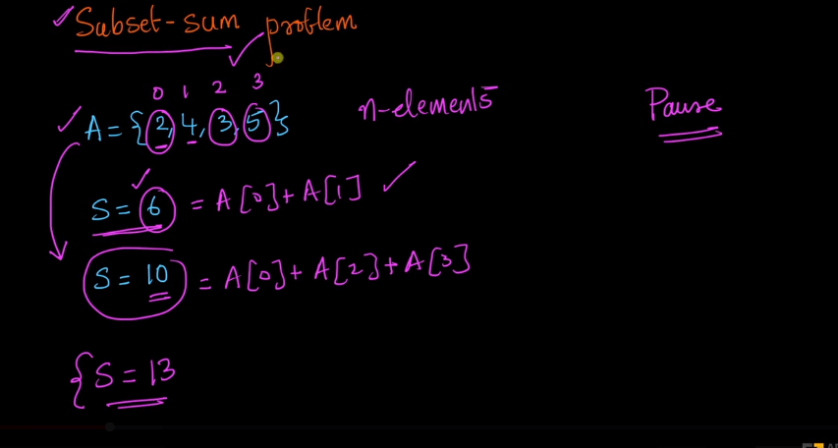

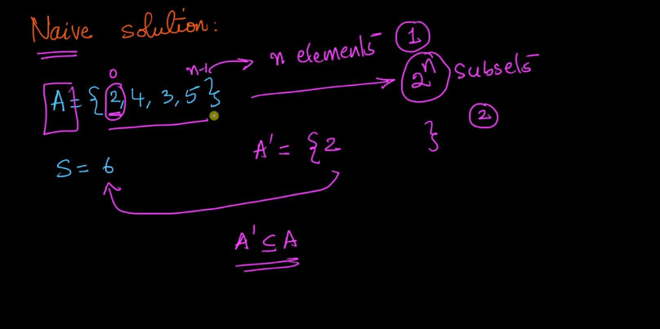

we can keep the element or discard it.

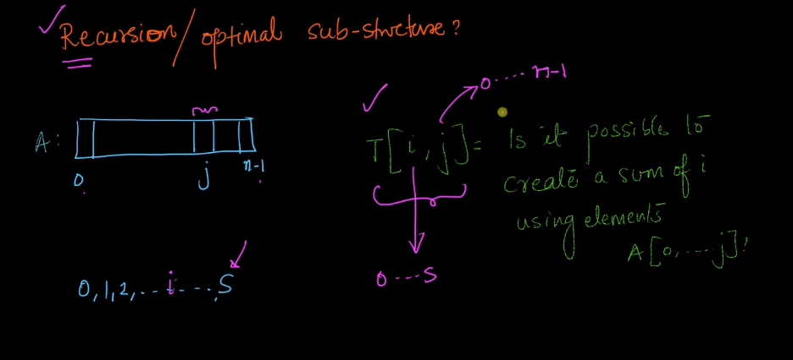

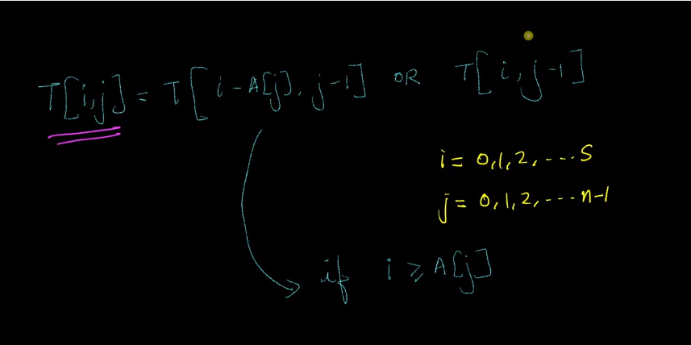

second part is if we can construct the sum with just j-1 element.

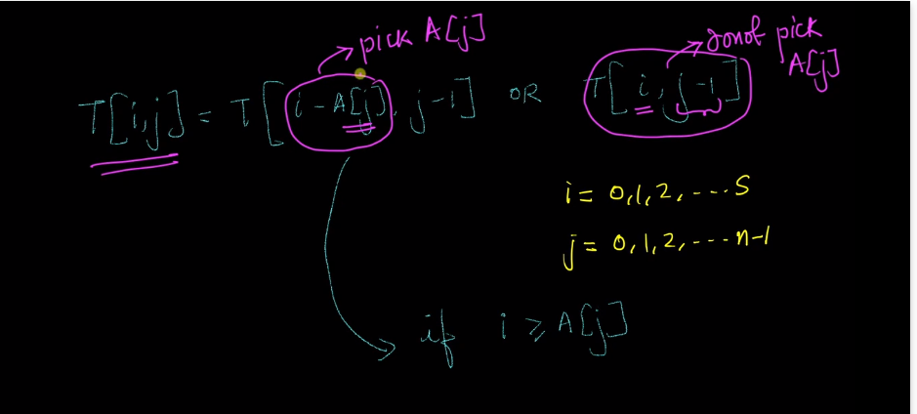

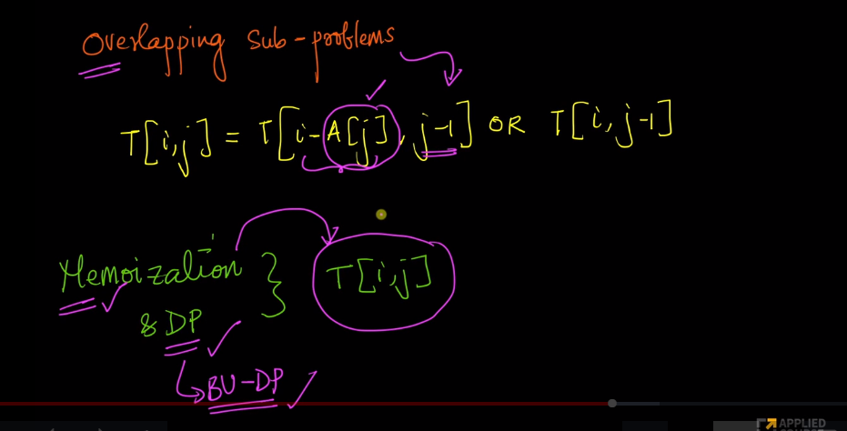

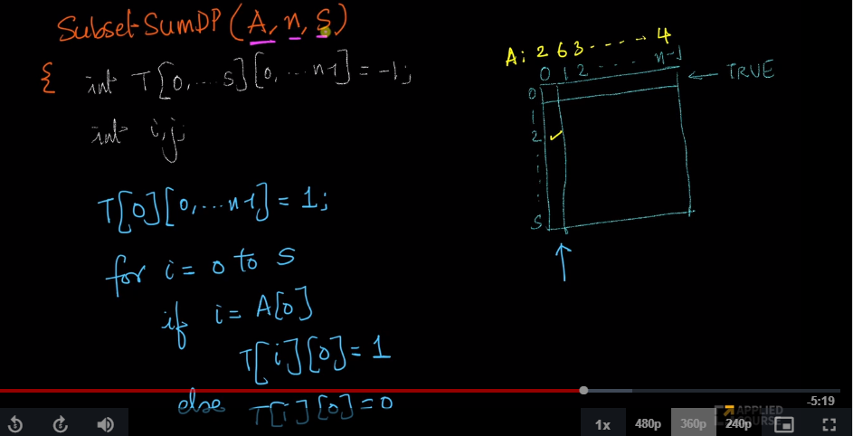

**Method 1:** Recursion.  
**Approach:** For the recursive approach we will consider two cases.

1. Consider the last element and now the **required sum = target sum – value of ‘last’ element** and **number of elements = total elements – 1**
2. Leave the ‘last’ element and now the **required sum = target sum**and **number of elements = total elements – 1**

Following is the recursive formula for isSubsetSum() problem.

isSubsetSum(set, n, sum)

= isSubsetSum(set, n-1, sum) ||

isSubsetSum(set, n-1, sum-set[n-1])

**Base Cases:**

isSubsetSum(set, n, sum) = false, if sum > 0 and n == 0

isSubsetSum(set, n, sum) = true, if sum == 0

Let’s take a look at the simulation of above approach-:

set[]={3, 4, 5, 2}

sum=9

(x, y)= 'x' is the left number of elements,

'y' is the required sum

(4, 9)

{True}

/ \

(3, 6) (3, 9)

/ \ / \

(2, 2) (2, 6) (2, 5) (2, 9)

{True}

/ \

(1, -3) (1, 2)

{False} {True}

/ \

(0, 0) (0, 2)

{True} {False}

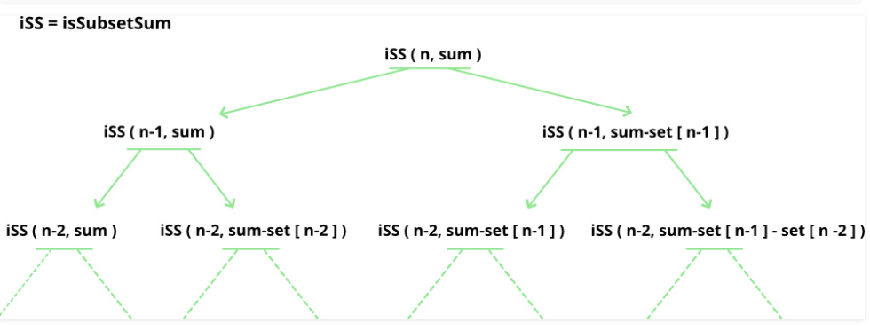

# A recursive solution for subset sum

# problem

# Returns true if there is a subset

# of set[] with sun equal to given sum

def isSubsetSum(set, n, sum):

    # Base Cases

    if (sum == 0):

        return True

    if (n == 0):

        return False

    # If last element is greater than

    # sum, then ignore it

    if (set[n - 1] > sum):

        return isSubsetSum(set, n - 1, sum)

    # else, check if sum can be obtained

    # by any of the following

    # (a) including the last element

    # (b) excluding the last element

    return isSubsetSum(

        set, n-1, sum) or isSubsetSum(

        set, n-1, sum-set[n-1])

**Method 2:** To solve the problem in [Pseudo-polynomial time](http://en.wikipedia.org/wiki/Pseudo-polynomial_time) use the Dynamic programming.  
So we will create a 2D array of size (arr.size() + 1) \* (target + 1) of type **boolean**. The state DP[i][j] will be **true** if there exists a subset of elements from A[0….i] with **sum value = ‘j’.** The approach for the problem is:

if (A[i] > j)

DP[i][j] = DP[i-1][j]

else

DP[i][j] = DP[i-1][j] OR DP[i-1][j-A[i]]

1. This means that if current element has value greater than ‘current sum value’ we will copy the answer for previous cases
2. And if the current sum value is greater than the ‘ith’ element we will see if any of previous states have already experienced the **sum=’j’ OR any previous states experienced a value ‘j – A[i]’** which will solve our purpose.

The below simulation will clarify the above approach:

set[]={3, 4, 5, 2}

target=6

0 1 2 3 4 5 6

0 T F F F F F F

3 T F F T F F F

4 T F F T T F F

5 T F F T T T F

2 T F T T T T T

|  |
| --- |
| # A Dynamic Programming solution for subset  # sum problem Returns true if there is a subset of  # set[] with sun equal to given sum    # Returns true if there is a subset of set[]  # with sun equal to given sum  def isSubsetSum(set, n, sum):        # The value of subset[i][j] will be      # true if there is a      # subset of set[0..j-1] with sum equal to i      subset =([[False for i in range(sum + 1)]              for i in range(n + 1)])        # If sum is 0, then answer is true      for i in range(n + 1):          subset[i][0] = True        # If sum is not 0 and set is empty,      # then answer is false      for i in range(1, sum + 1):           subset[0][i]= False        # Fill the subset table in botton up manner      for i in range(1, n + 1):          for j in range(1, sum + 1):              if j<set[i-1]:                  subset[i][j] = subset[i-1][j]              if j>= set[i-1]:                  subset[i][j] = (subset[i-1][j] or                                  subset[i - 1][j-set[i-1]])        # uncomment this code to print table      # for i in range(n + 1):      # for j in range(sum + 1):      # print (subset[i][j], end =" ")      # print()      return subset[n][sum]    # Driver code  if \_\_name\_\_=='\_\_main\_\_':      set = [3, 34, 4, 12, 5, 2]      sum = 9      n = len(set)      if (isSubsetSum(set, n, sum) == True):          print("Found a subset with given sum")      else:          print("No subset with given sum")    # This code is contributed by  # sahil shelangia. |

**Output**

Found a subset with given sum

**Complexity Analysis:**

* **Time Complexity:** O(sum\*n), where sum is the ‘target sum’ and ‘n’ is the size of array.
* **Auxiliary Space:** O(sum\*n), as the size of 2-D array is sum\*n.

# Unique Paths: Problem Statment [Leetcode]

**Problem Statement:**  
  
A robot is located at the top-left corner of a *m* x *n* grid (marked 'Start' in the diagram below).  
  
The robot can only move either down or right at any point in time. The robot is trying to reach the bottom-right corner of the grid (marked 'Finish' in the diagram below).  
  
How many possible unique paths are there?

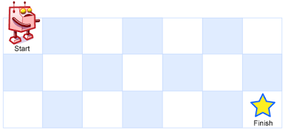  
  
Above is a 7 x 3 grid. How many possible unique paths are there?

**Example 1:  
  
Input:** m = 3, n = 2  
  
**Output:** 3  
  
**Explanation:** From the top-left corner, there are a total of 3 ways to reach the bottom-right corner:  
  
1. Right -> Right -> Down  
  
2. Right -> Down -> Right  
  
3. Down -> Right -> Right  
  
**Example 2:  
  
Input:** m = 7, n = 3 **Output:** 28  
  
**Constraints:**  
  
1 <= m, n <= 100  
  
It's guaranteed that the answer will be less than or equal to 2 \* 10^9.

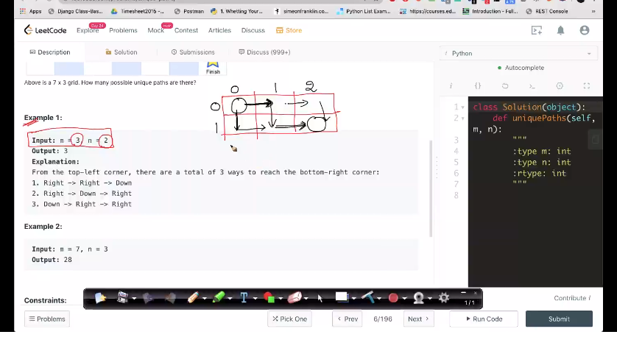

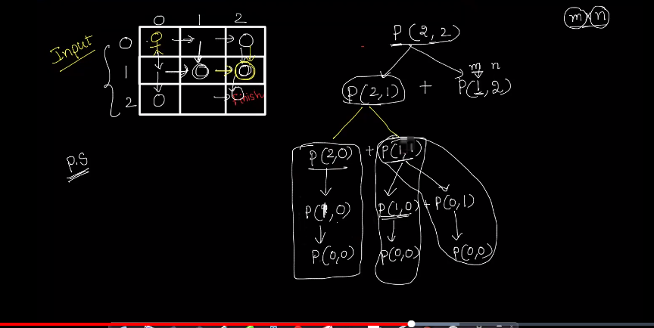

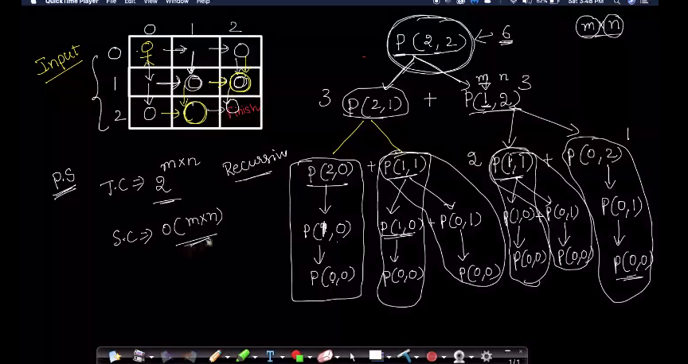

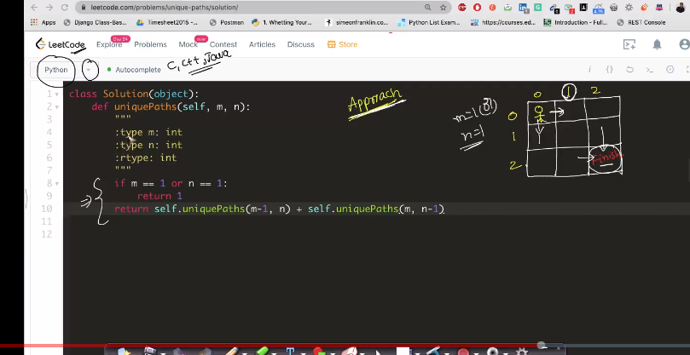

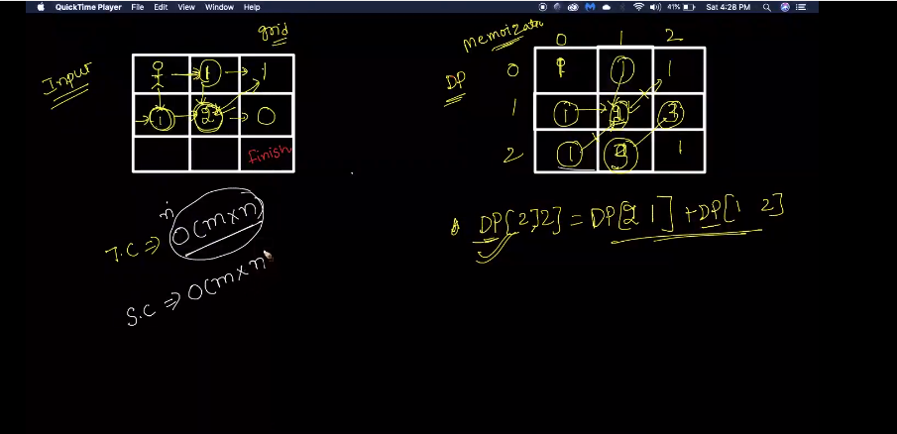

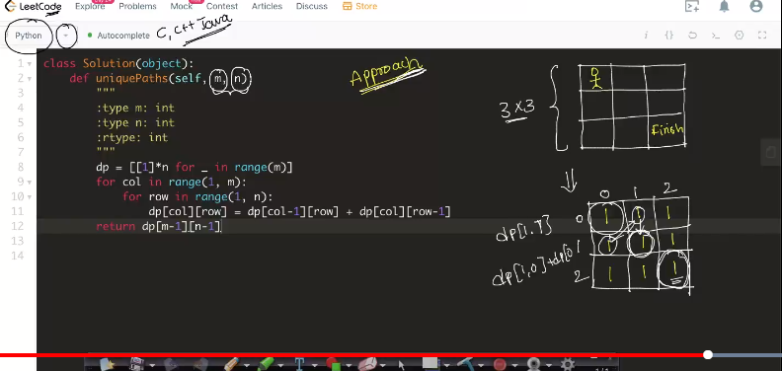

# Unique Binary Search Trees: Problem Statement [Leetcode]

**Problem Statement:**

Given *n*, how many structurally unique **BST's** (binary search trees) that store values 1 ... *n*?

**Example:**

**Input:** 3

**Output:** 5

**Explanation:**

Given *n* = 3, there are a total of 5 unique BST's:

1 3 3 2 1

\ / / / \ \

3 2 1 1 3 2

/ / \ \

2 1 2 3

**Level: Medium**

**Problem Practice Link:** [https://leetcode.com/problems/unique-binary-search-trees/](https://leetcode.com/problems/unique-binary-search-trees/" \t "_blank)

**Similar Problems:**

Unique Binary Search Trees !!: <https://leetcode.com/problems/unique-binary-search-trees-ii/>

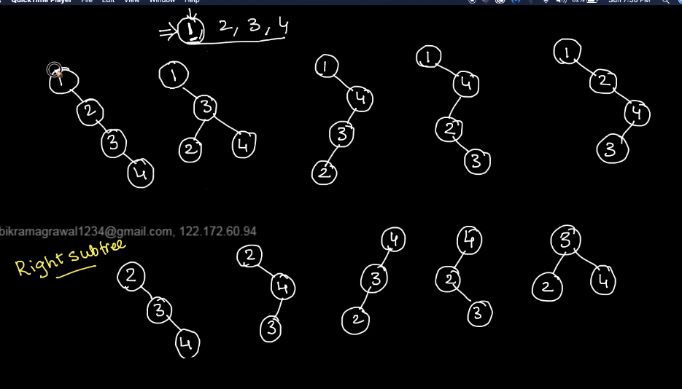

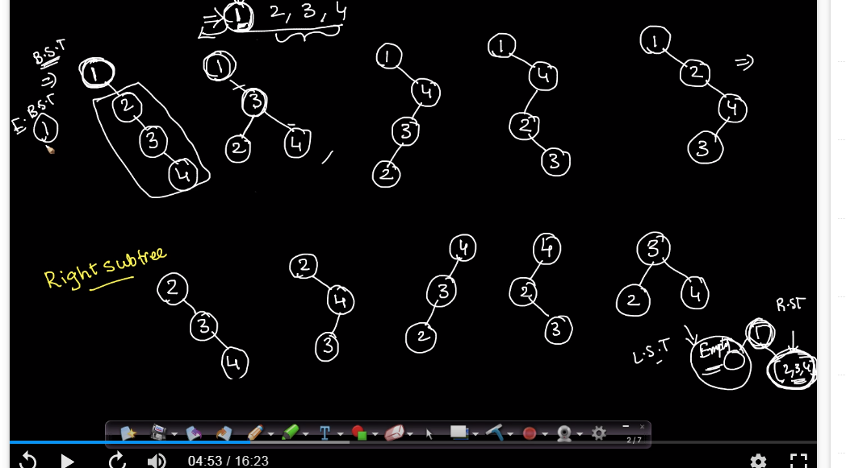

on the left we have one binary tree which can be told as a binary tree. If we are taking only 1 as a root node.

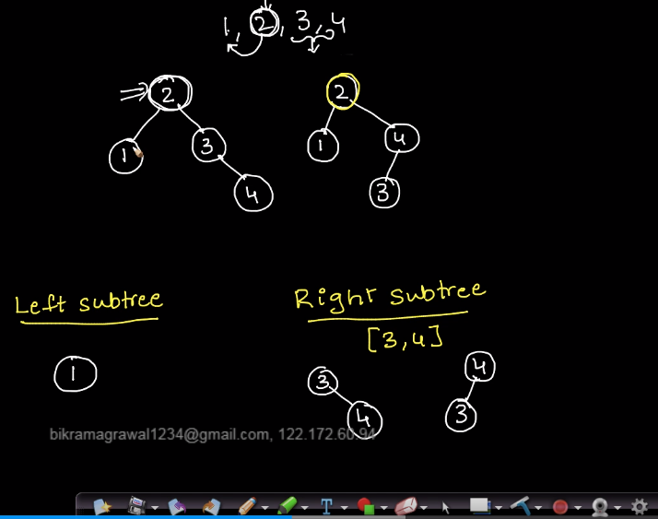

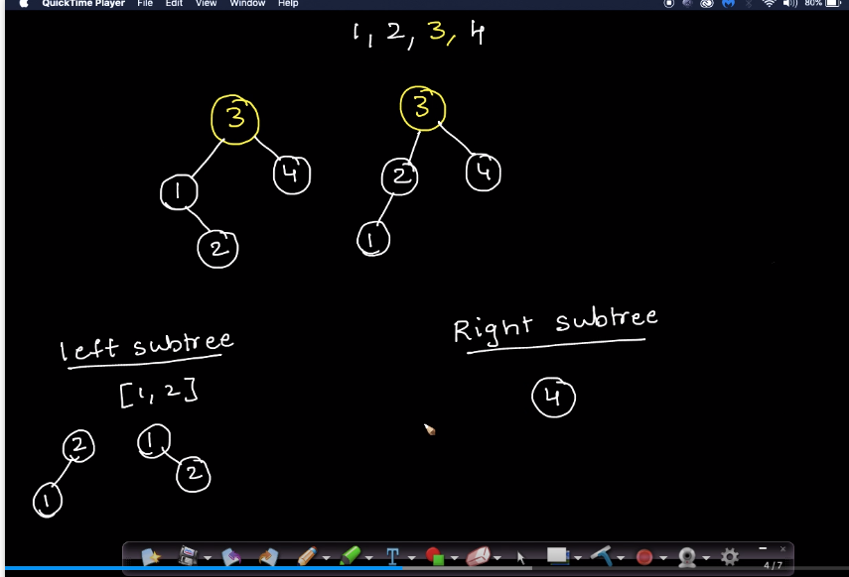

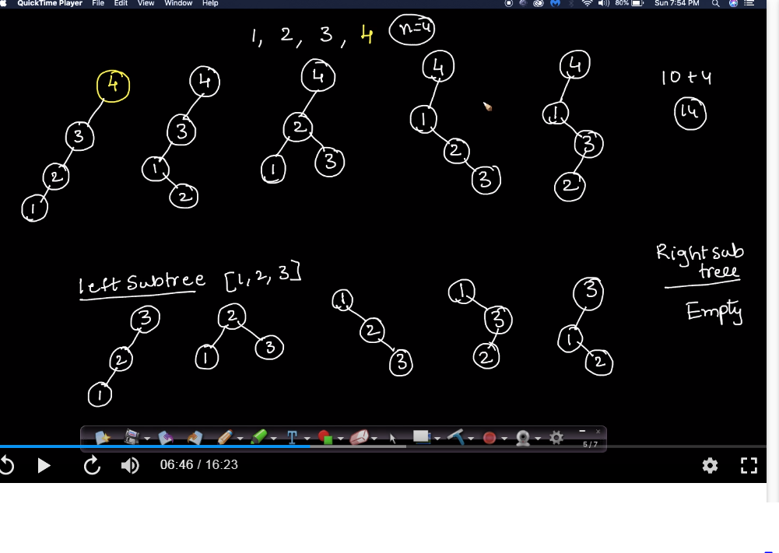

Total 14 binary tree.

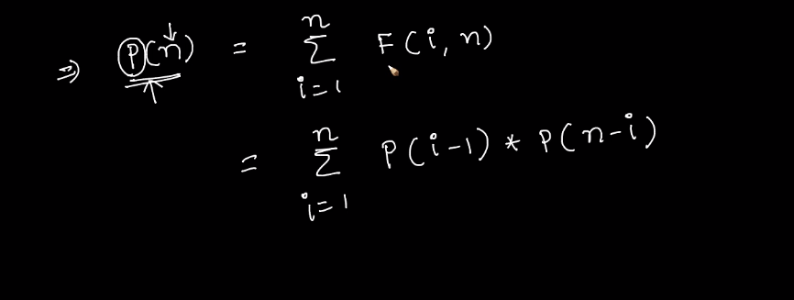

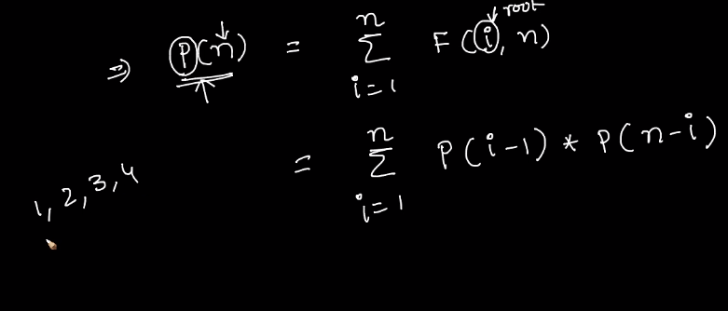

p(i-1) are the values present in left sub tree.

p(n-i) are the values present in right subtree.

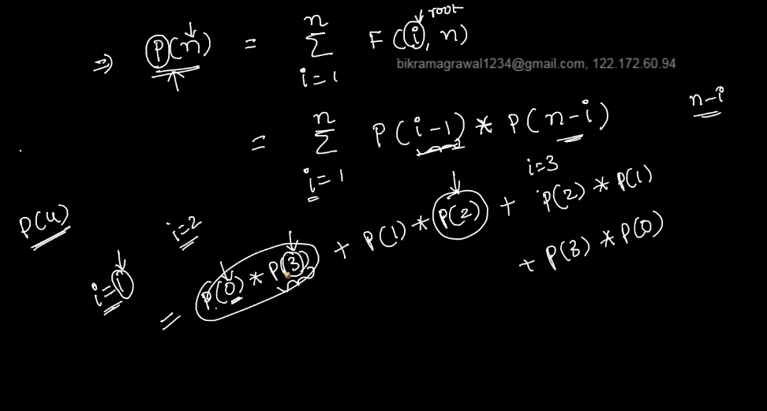

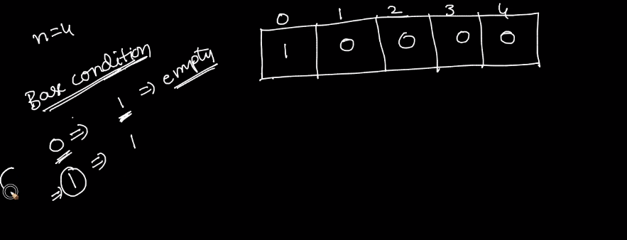

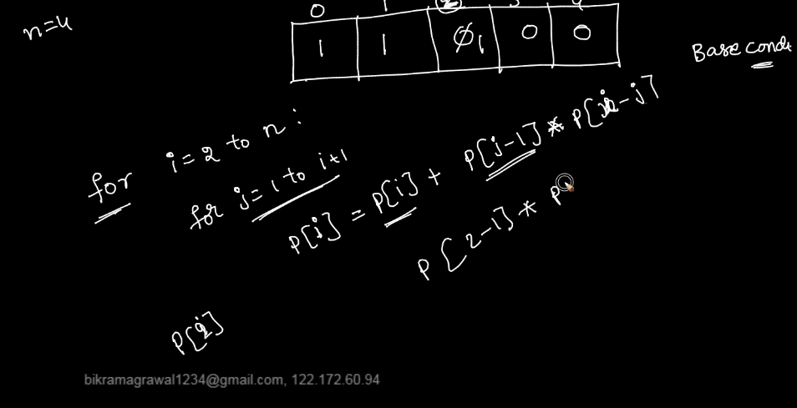

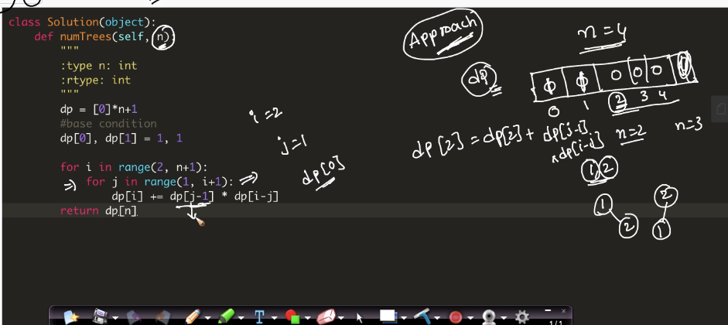

# House Robber: Problem Statment [Leetcode]

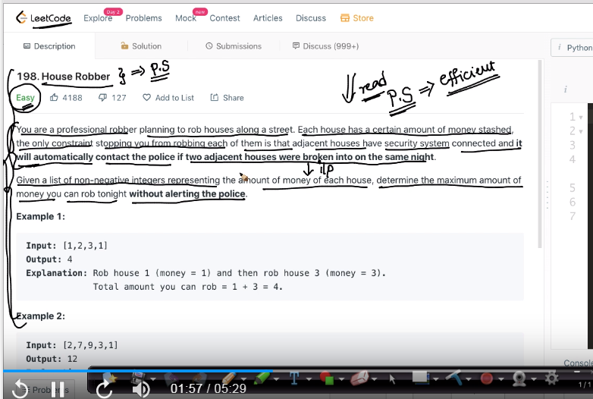

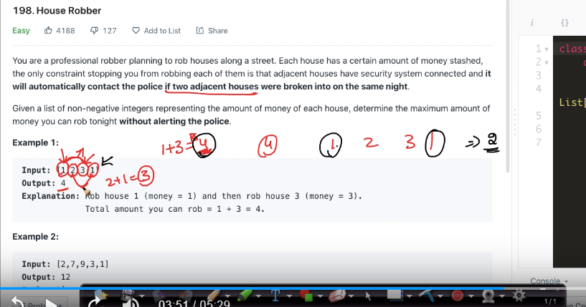

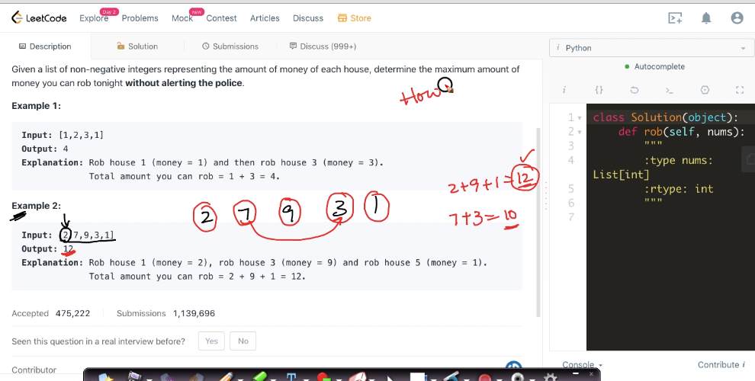

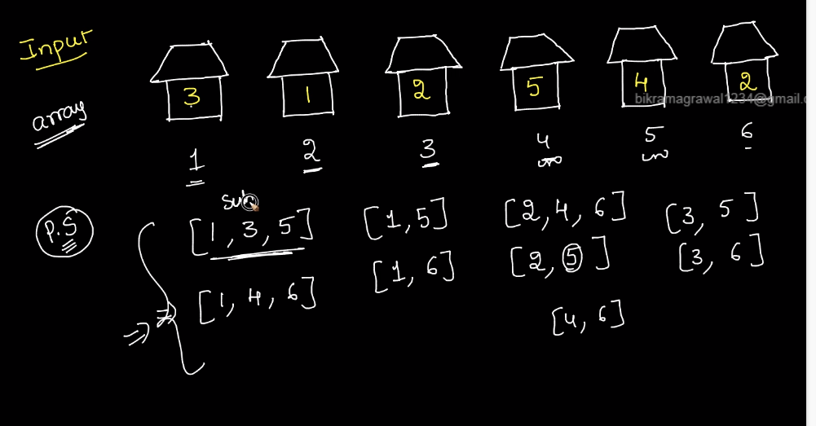

these are the subset of the array.which has a subset of array has maximum value, we will take it.

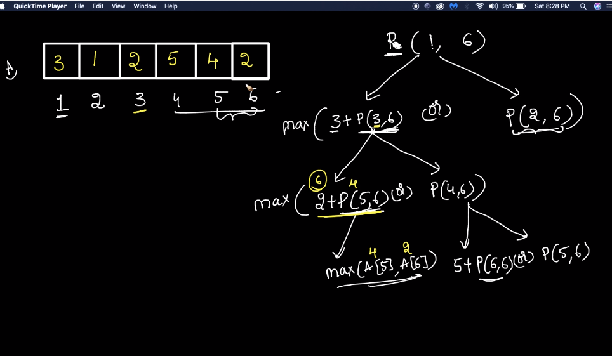

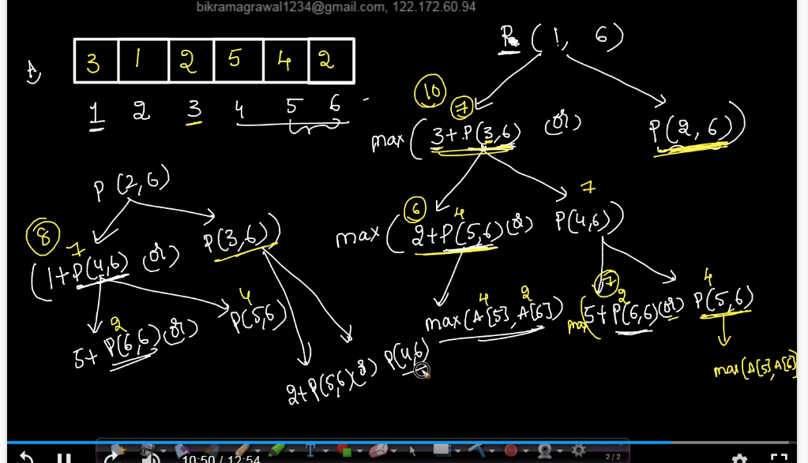

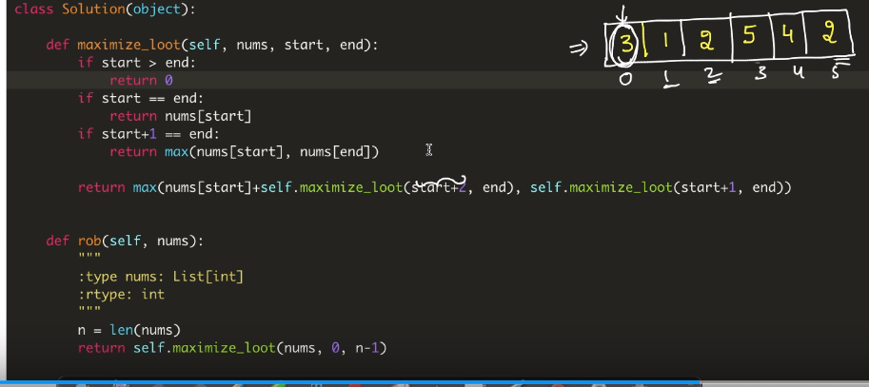

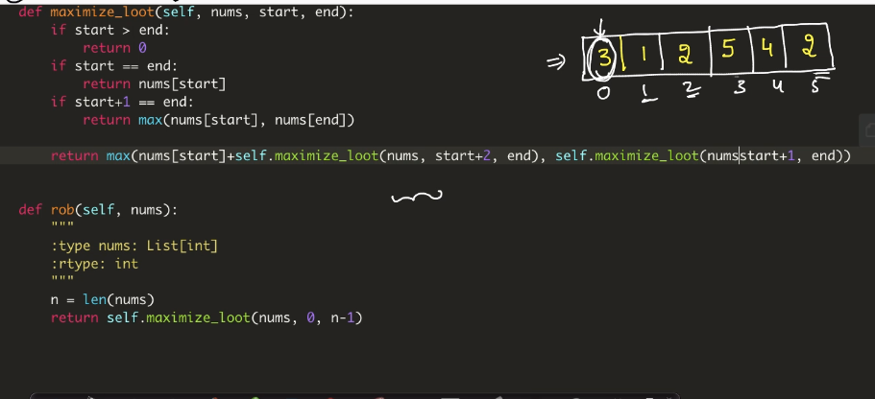

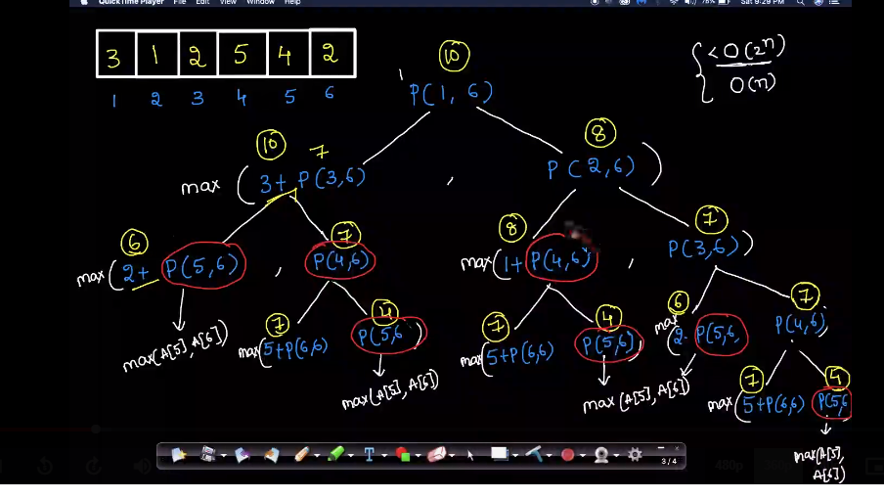

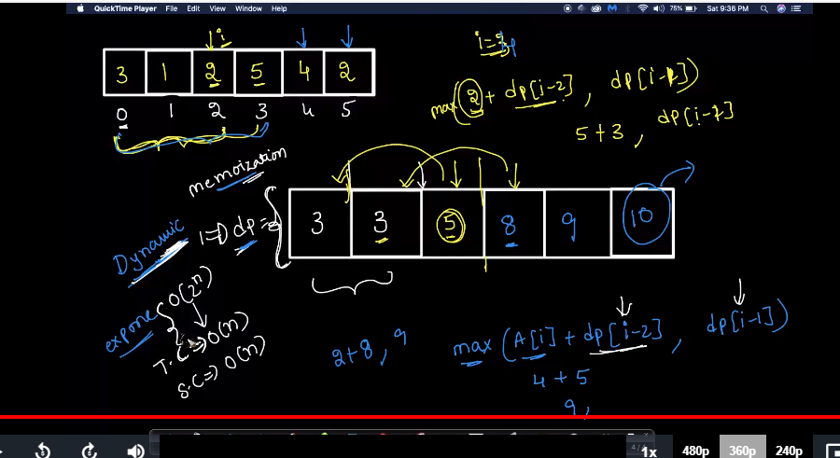

**Problem Practice Link:**<https://leetcode.com/problems/house-robber/>  
  
**Similar Questions:**  
  
1. Maximum Product sub array: <https://leetcode.com/problems/maximum-product-subarray/>  
  
2. House Robber !!: <https://leetcode.com/problems/house-robber-ii/>  
  
3. Paint House: <https://leetcode.com/problems/paint-house/>  
  
4. House Robber III: <https://leetcode.com/problems/house-robber-iii/>  
  
5. Coin Path: <https://leetcode.com/problems/coin-path/>

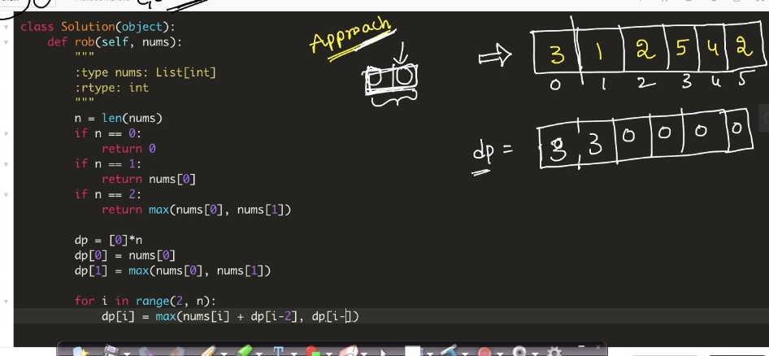

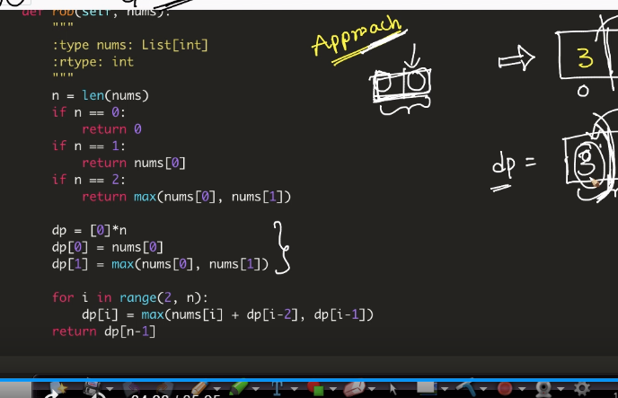

# Longest Palindromic Substring: Problem Statement [Leetcode]

**Problem Statment:**  
  
  
  
Given a string **s**, find the longest palindromic substring in **s**. You may assume that the maximum length of **s** is 1000.  
  
 

**Example 1:**

**Input:** "babad"

**Output:** "bab"

**Note:** "aba" is also a valid answer.

**Example 2:**

**Input:** "cbbd"

**Output:** "bb"

**Level: Medium**

**Problem Practice Link:**[**https://leetcode.com/problems/longest-palindromic-substring/**](https://leetcode.com/problems/longest-palindromic-substring/)